**LORELLA**

Ruched Corset Dress in Beige

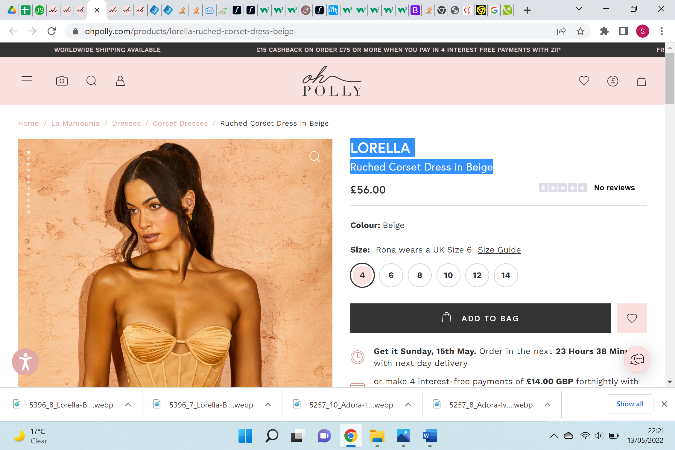

**VALENKA**

# One Shoulder Cut Out Mini Dress in Orange

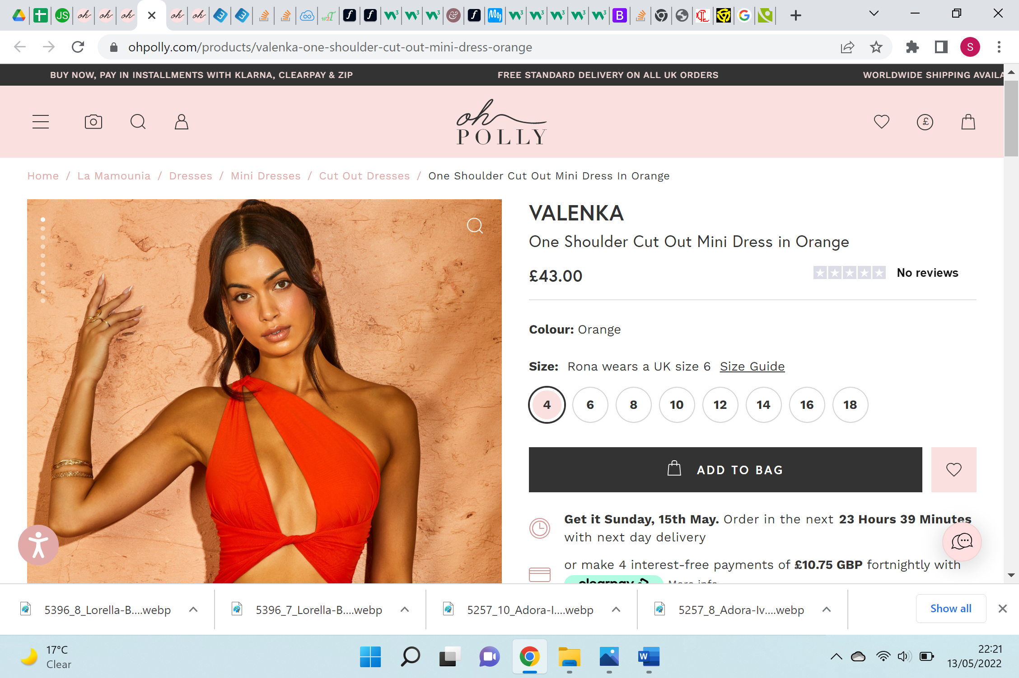

**CLEO**

# Sweetheart Mini Dress Ivory

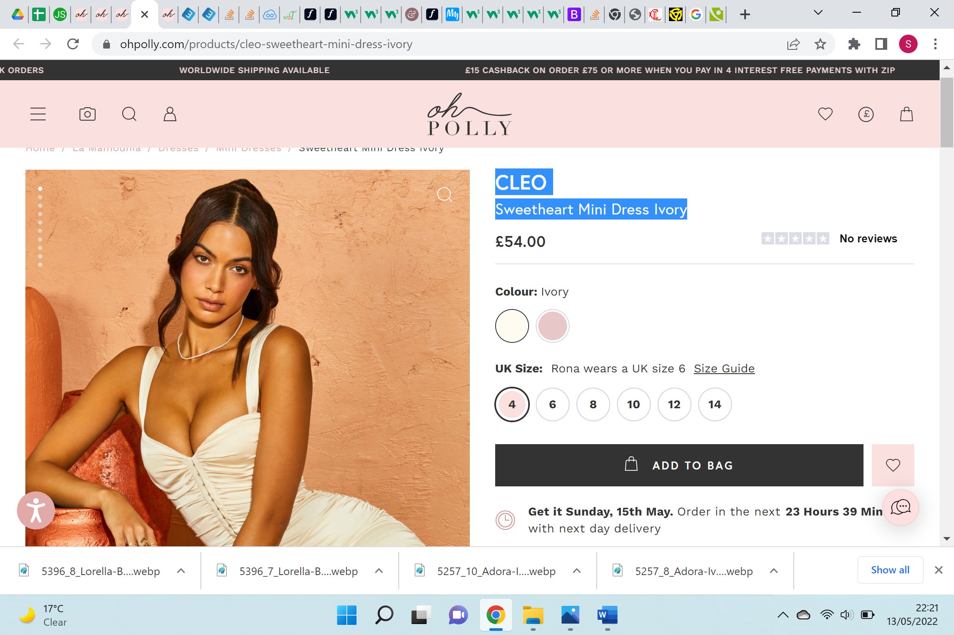

**ADORA**

# Low Plunge Ruched Dress in Ivory

